Protocol for Treating Peripheral Arterial Disease (PAD) - Ischemic Leg Pain Using Low-
Intensity Shockwaves
Device: MoreNova DT, MoreNova Pro with C30 Transducer.
Document Version: 2.0
Date: 17/12/25
1
. Purpose and Scope
This protocol provides a standardized treatment plan for using low-intensity shockwaves to
manage Peripheral Arterial Disease (PAD), particularly in patients experiencing intermittent
claudication (pain in the legs after walking due to reduced blood flow). It is intended for
healthcare providers using the MoreNova Device with the C30 Transducer to enhance
circulation, promote angiogenesis, and relieve ischemic pain in the lower limbs.
2
. Introduction
PAD is a condition caused by atherosclerosis, leading to reduced blood supply to the lower
extremities. Common symptoms include leg pain after walking (claudication), numbness, and
slow-healing wounds. Low-Intensity Extracorporeal Shockwave Therapy (LiESWT) has been
shown to stimulate blood vessel formation, improve circulation, and reduce ischemic pain,
providing a non-invasive alternative to surgical interventions.
3
. Scientific Review
Current Treatments:
•
Medications (antiplatelets, vasodilators) help reduce symptoms but do not reverse
damage.
•
•
Exercise therapy improves walking distance but is limited by pain.
Surgery (angioplasty, bypass) is effective but invasive and costly.
Advantages of LiESWT:
•
•
•
Non-invasive, painless treatment option.
Stimulates angiogenesis and microcirculation in ischemic muscles.
Reduces inflammation and enhances endothelial function.
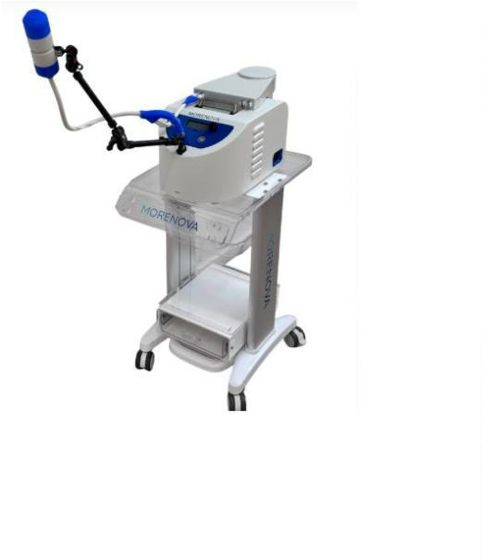

4
. Patient Selection Criteria
Inclusion Criteria:
1
2
. Adults (18–80 years) diagnosed with PAD (Stage I–II Fontaine classification).
. Intermittent claudication (pain after walking) with reduced ankle-brachial index (ABI
0.9).
. Non-healing ulcers secondary to PAD.
<
3
Exclusion Criteria:
1
2
3
4
.
.
.
.
Electromagnetic Sensitive Devices: Presence of implanted devices such as pacemakers,
cardioverters, defibrillators (ICD), or neurostimulators.
Metallic or Electronic Implants: Any metallic or electronic implants in or near the treatment
area (e.g., orthopedic screws, radioisotope needles).
Malignancy: Known or suspected malignancy at or near the treatment site, or history of cancer
within the last 1 years.
Coagulation & Hematological Disorders: Bleeding disorders, clinically significant chronic
hematological disease, or use of blood thinners (e.g., Coumadin) with an INR > 3.
5
6
7
.
.
.
Gas-Filled Organs: Treatment directly over the lungs or bowel.
Active Infection: Including cellulitis, abscess, osteomyelitis, or systemic infection.
Psychological Pathology: Psychiatric or psychological conditions that may impede the treatment
process.
8
9
1
1
1
1
1
.
.
Past Radiotherapy: Previous radiation treatment in the target region.
Critical Limb Ischemia: Including rest pain, non-healing ischemic ulcers, or gangrene.
0. Acute Vascular Events: Acute arterial thrombosis or embolism.
1. Vascular Aneurysm: Known aneurysm at or near the treatment site.
2. Severe PAD: Peripheral Arterial Disease with an Ankle-Brachial Index (ABI) < 0.4.
3. Uncontrolled Hypertension: High blood pressure that is not medically managed.
4. Cardiac Instability: Severe cardiac conditions, including recent Myocardial Infarction (MI) or
unstable angina.
5
. Pre-Treatment Screening
•
•
•
•
Medical history review to assess severity.
Physical examination focusing on ABI measurements and pulse evaluation.
Doppler ultrasound or angiography to evaluate arterial flow.
Pain assessment using the Visual Analog Scale (VAS).

6
. Treatment Protocol
Procedure:
•
•
•
•
•
•
•
Number of Sessions: 6–10 sessions.
Session Frequency: Once-Twice per week.
Session Duration: 15-20 minutes.
Number of applications: 5.
Shocks Per Application: 500- per region.
Energy (HV) Settings: 1.9 kV.
Frequency (FRQ): 2 Hz.
Target Areas:
•
•
•
Calves: Gastrocnemius and soleus muscles.
Thighs: Femoral artery region for collateral circulation.
Foot: Plantar arch if symptoms extend to distal limbs.
7
8
. Post-Treatment Care
•
•
•
Encourage patients to walk daily to reinforce angiogenesis.
Maintain proper hydration and balanced diet to support vascular health.
Monitor ABI and adjust treatment plan accordingly.
. Expected Outcomes
•
•
•
Increased walking distance without pain within 4–6 weeks.
Improved ABI scores and microcirculation.
Reduction in limb pain and muscle fatigue.
9
1
. Follow-Up
•
•
•
Schedule follow-ups at 4 weeks and 12 weeks post-treatment.
Assess ABI, pain reduction, and walking performance.
Consider maintenance sessions every 3-6 months.
References
0.
For clinical studies and additional resources, visit the Initia medical Clinical Data Center.

